**IBM NAAN MUDHALVAN**

**DOMAIN – DATA ANALYTICS WITH COGNOS**

|  |  |
| --- | --- |
| **Date** | 18.10.2023 |
| **Team_ID** | PROJ_224694_TEAM_2 |
| **Title** | CUSTOMER CHURN PREDICTION-TELECOMMUNICATION CUSTOMER CHURN PREDICTION |

**DATA PREPROCESSING USING JUPYTER:**

**Importing Packages**

Import **pandas , numpy** libraries for data handling and **matplotlib , seaborn** libraries for data visualization.

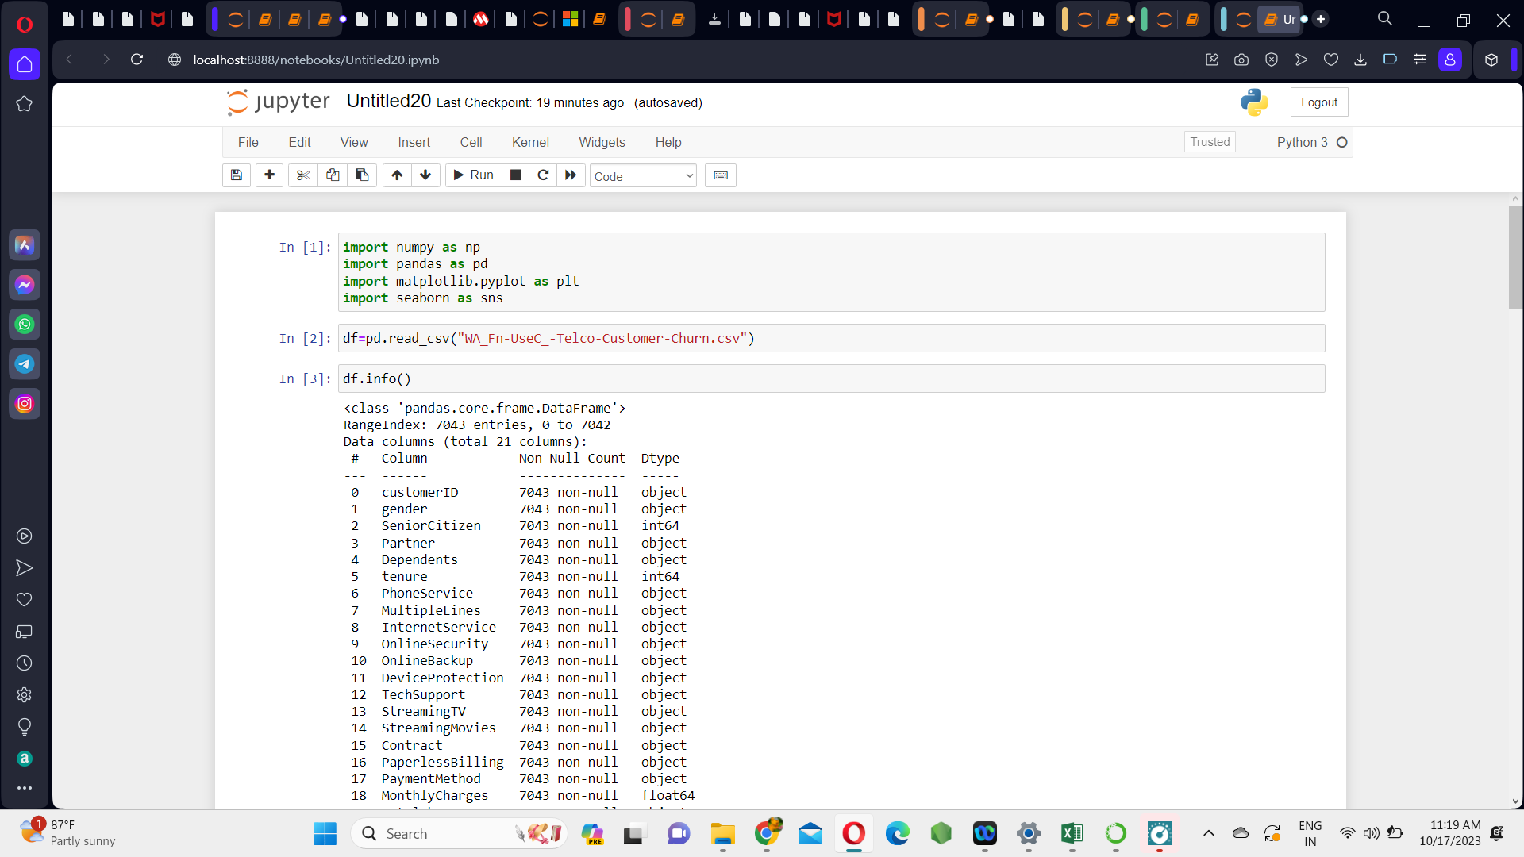

**Loading Telecom Customer Churn Dataset**

Now, load the Telecommunication churn dataset (csv file) by using the function pd.read_csv()

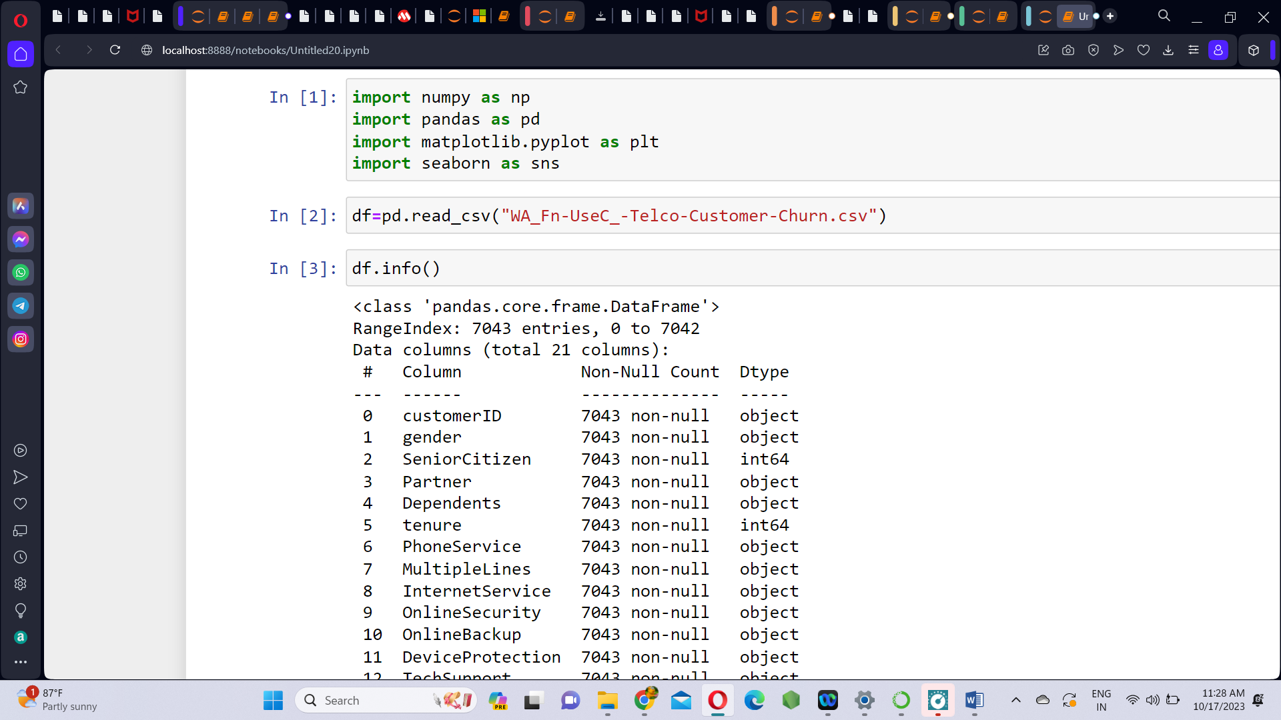

**Information about Dataset**

The dataset has 21 columns and 7043 rows. Use df.info() and df.head() functions to know about the dataset.

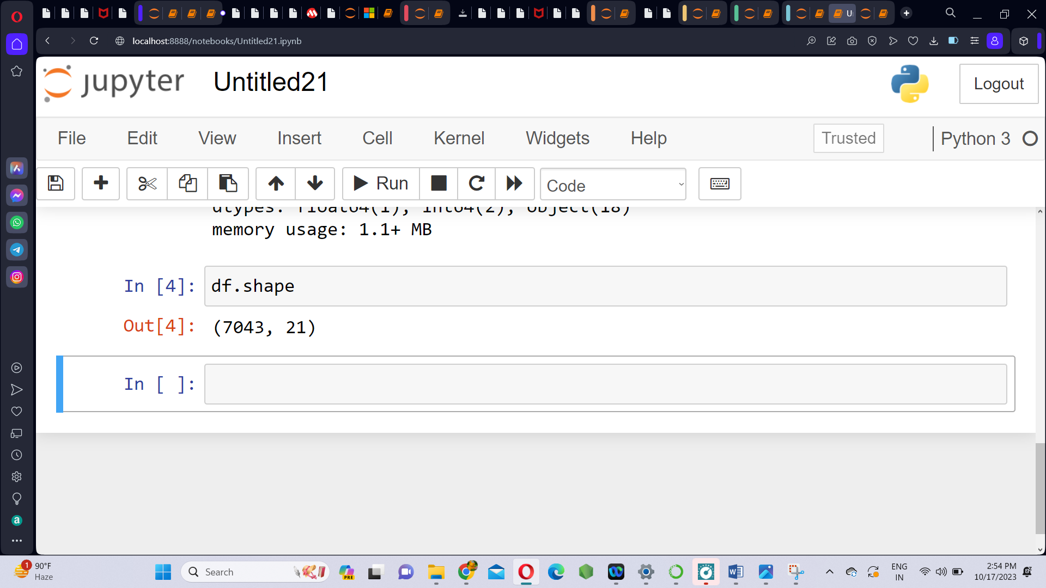

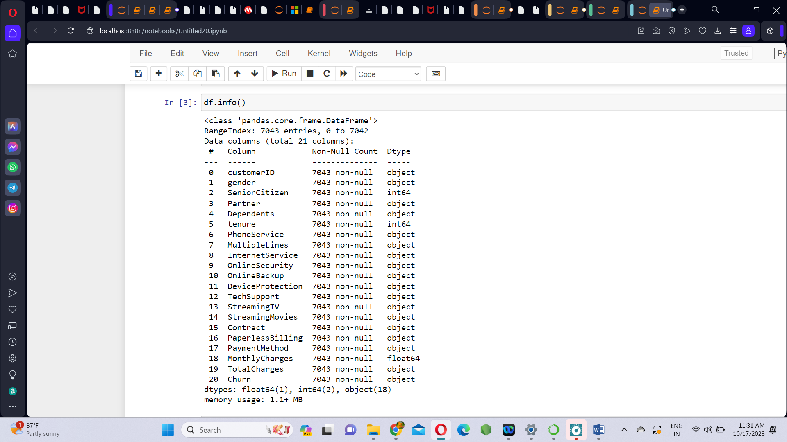

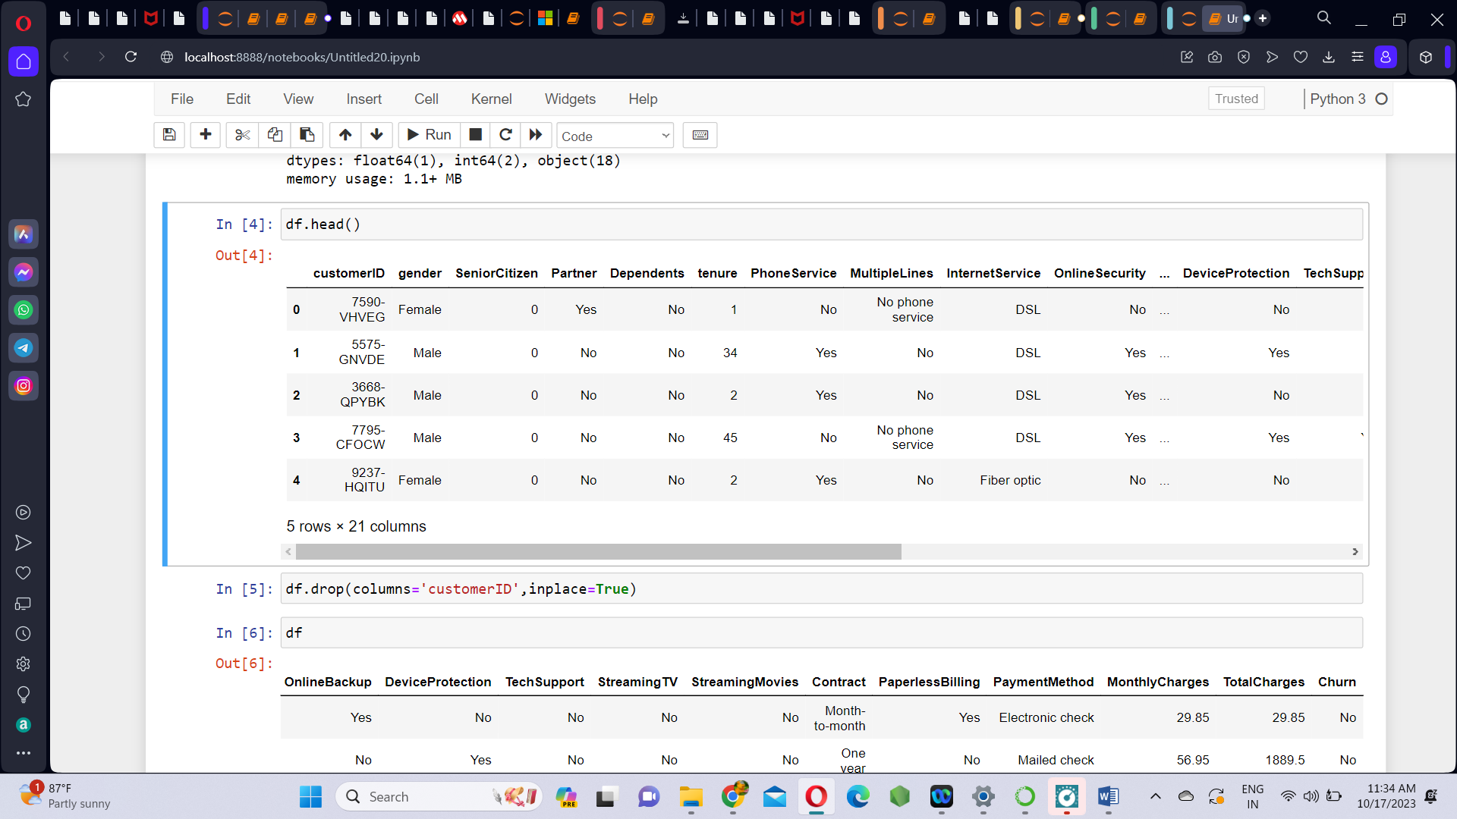

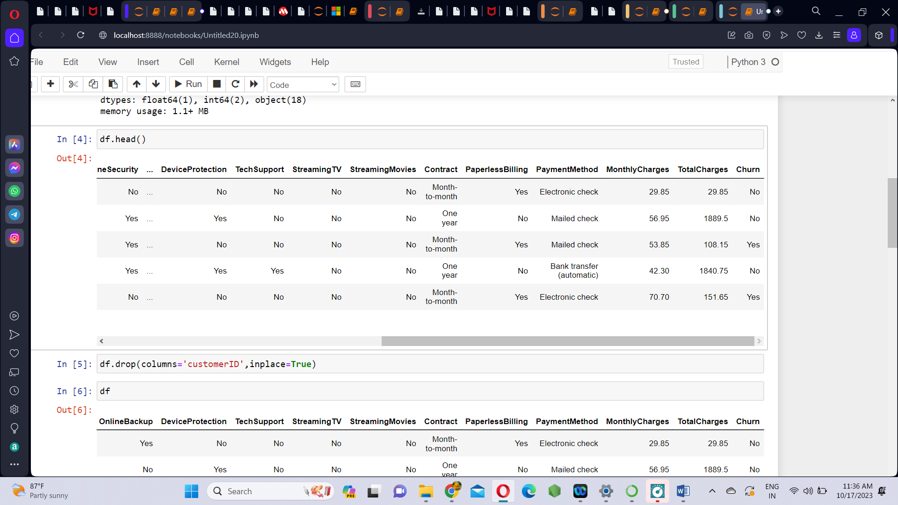

**Data Cleaning:**

1. Remove unwanted column - customer ID. As the column ‘customerID’ does not tell about whether the cutomer will churn or not. So we remove it.

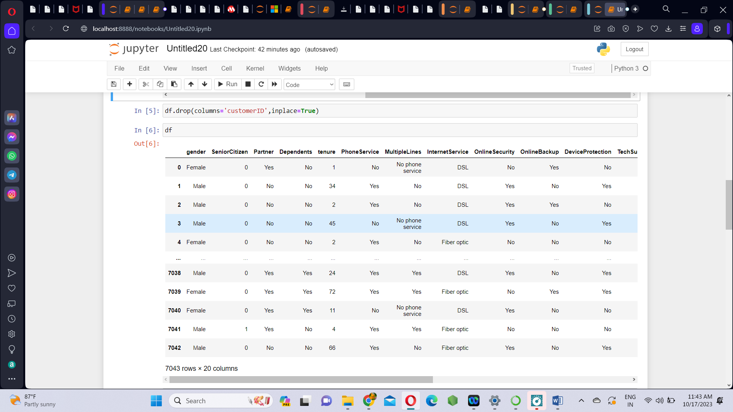

1. Check the null values using isna() function.

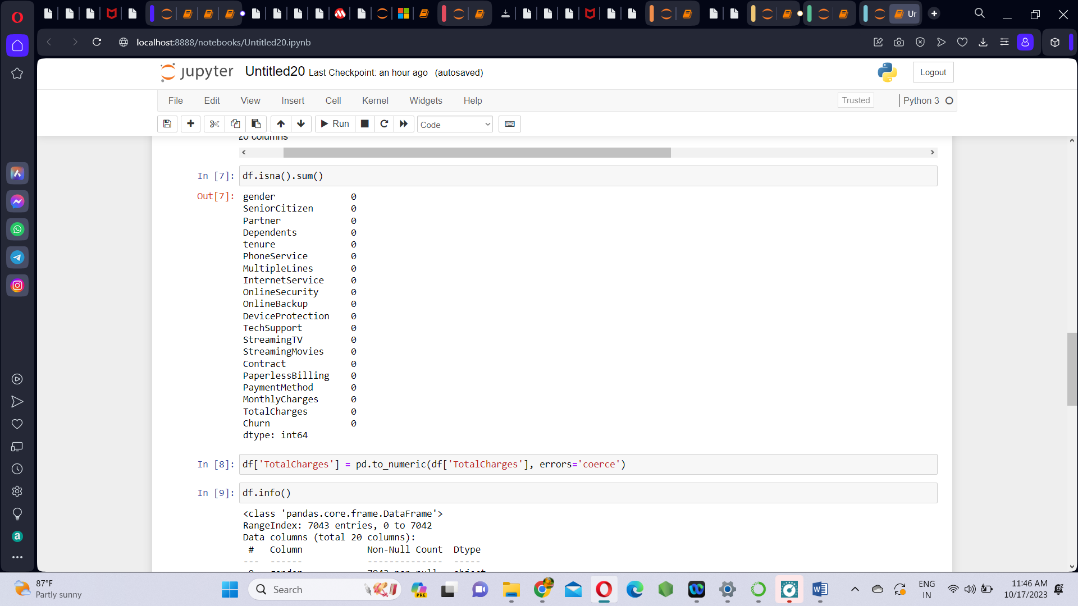

There are no null values in any of the columns of the dataset.

1. **Convert ‘TotalCharges’ from object to float datatype:**

The column ‘TotalCharges’ is actually contains float values but it is mentioned as object. So we change it into numeric.

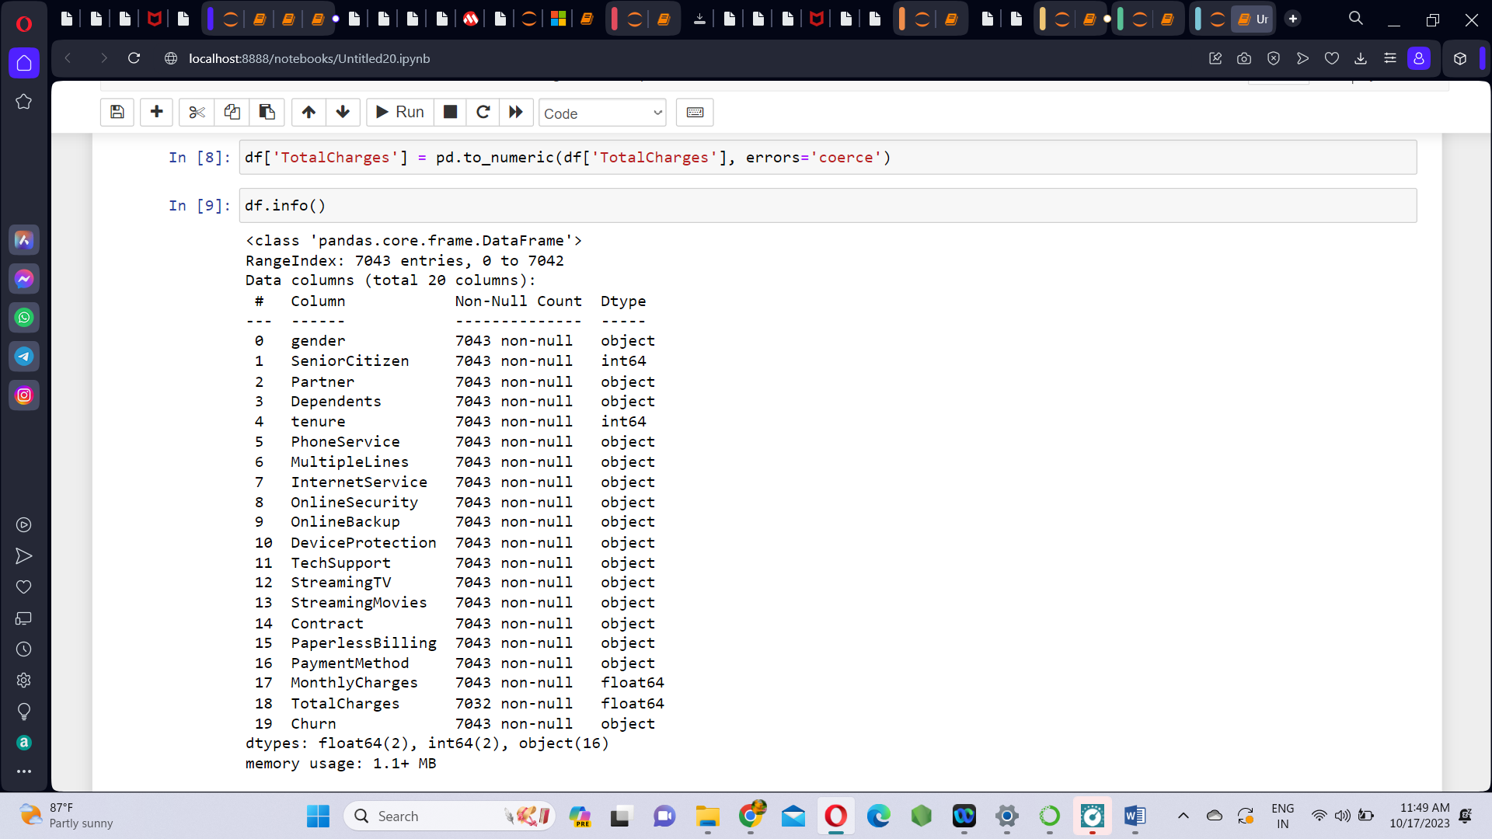

1. **Removing ‘(automatic)’ string from PaymentMethod column:**

Under the PaymentMethod column, the values Bank transfer and Credit card has (automatic) in them which is unwanted. So we replace the string ‘(automatic)’ with an empty string.

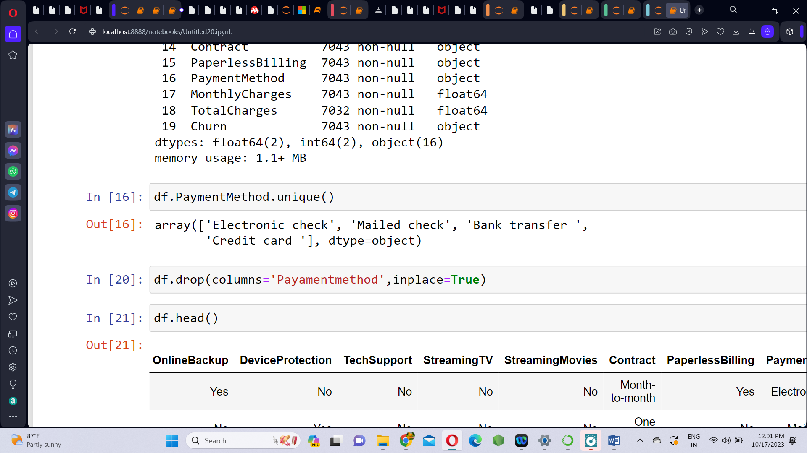

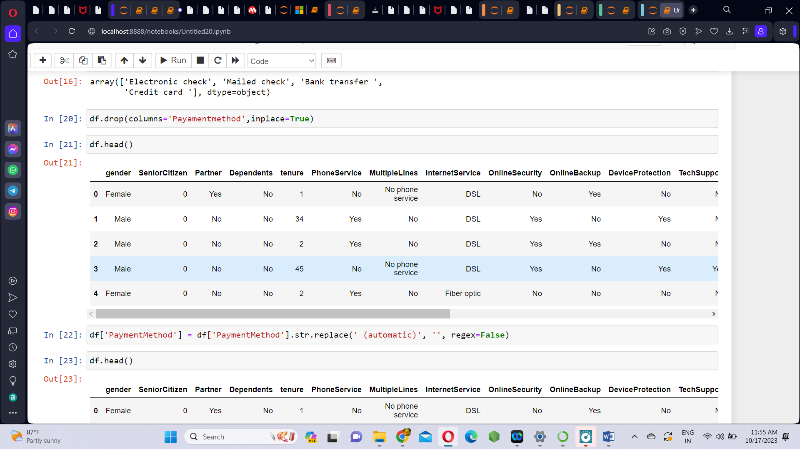

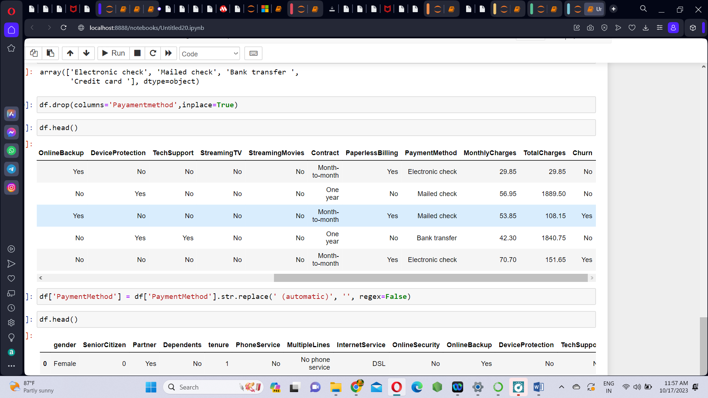

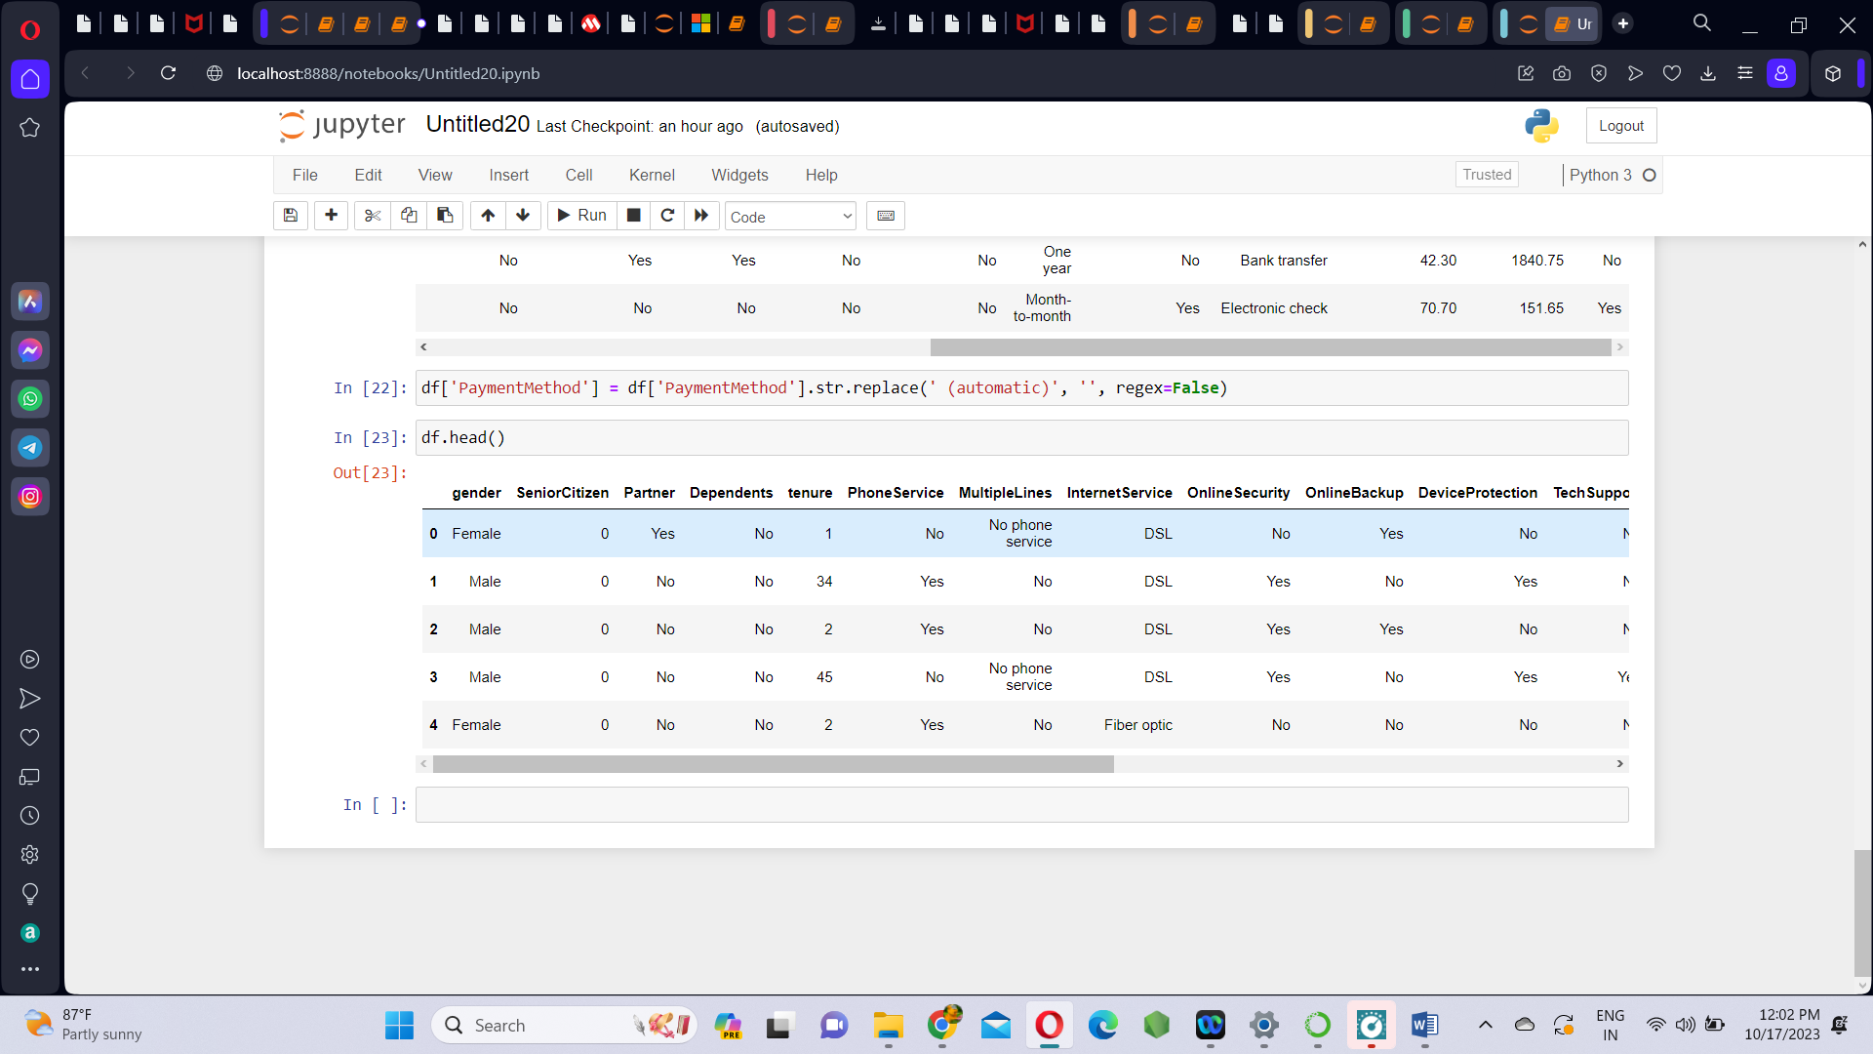

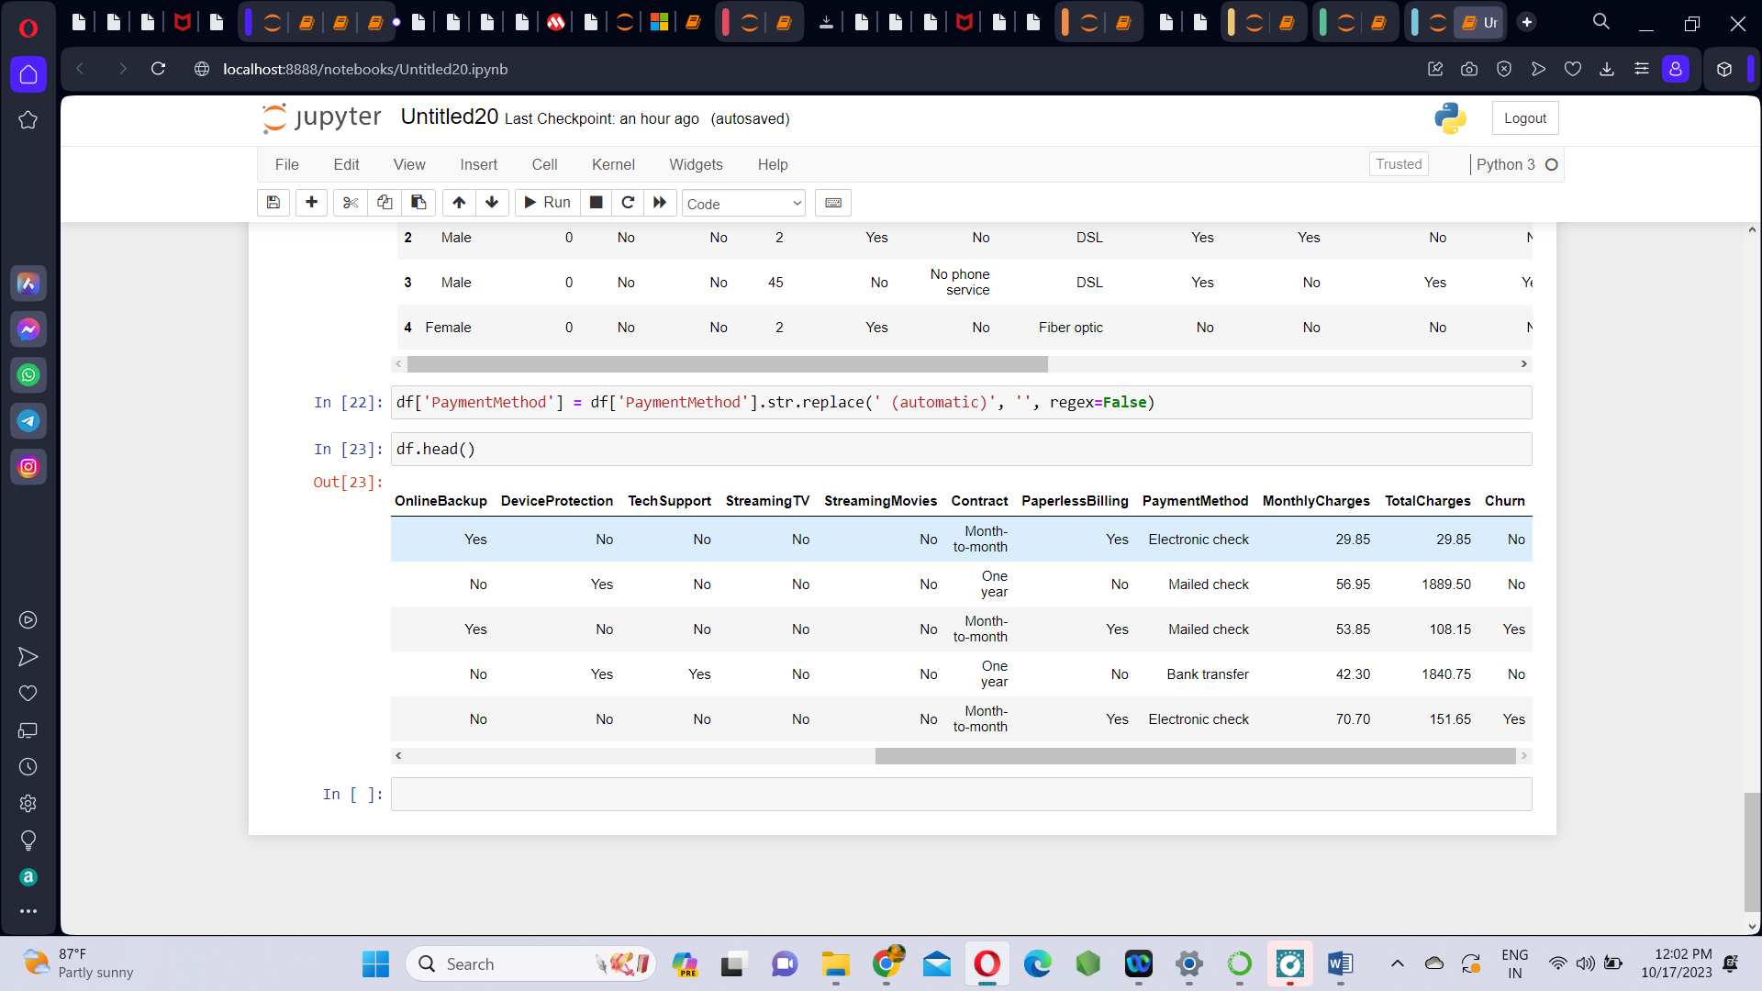

**DATA VISUALIZATION USING IBM COGNOS ANALYTICS:**

**Step1:** Upload the dataset.

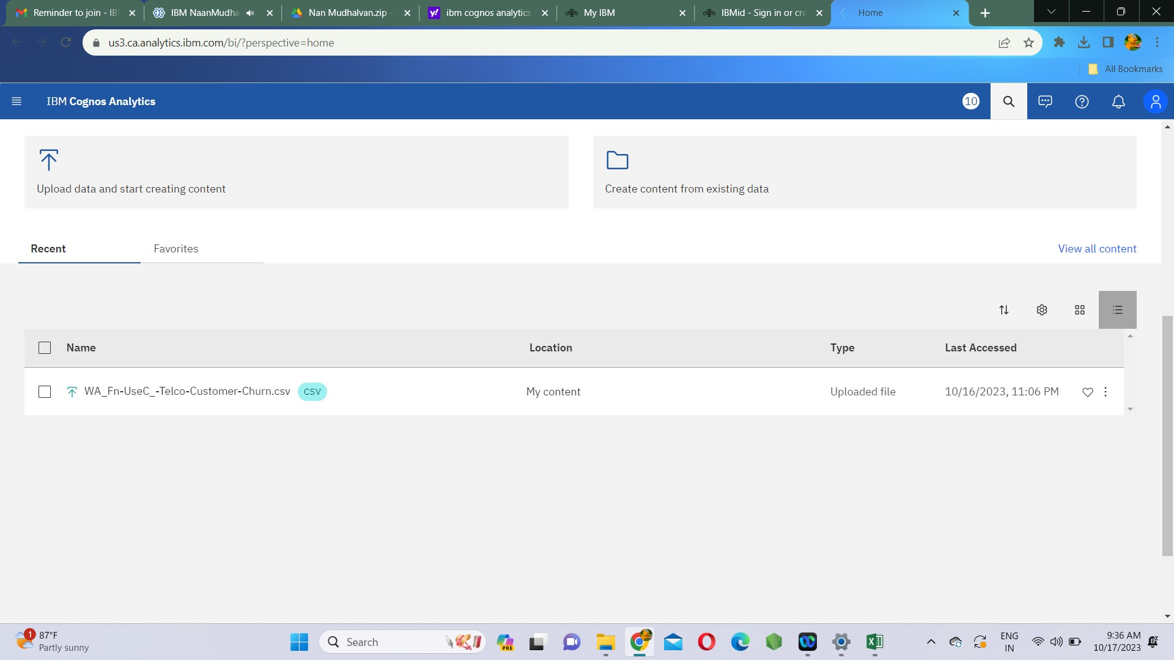

**Step2:** Create and save data module as Customer churn module.

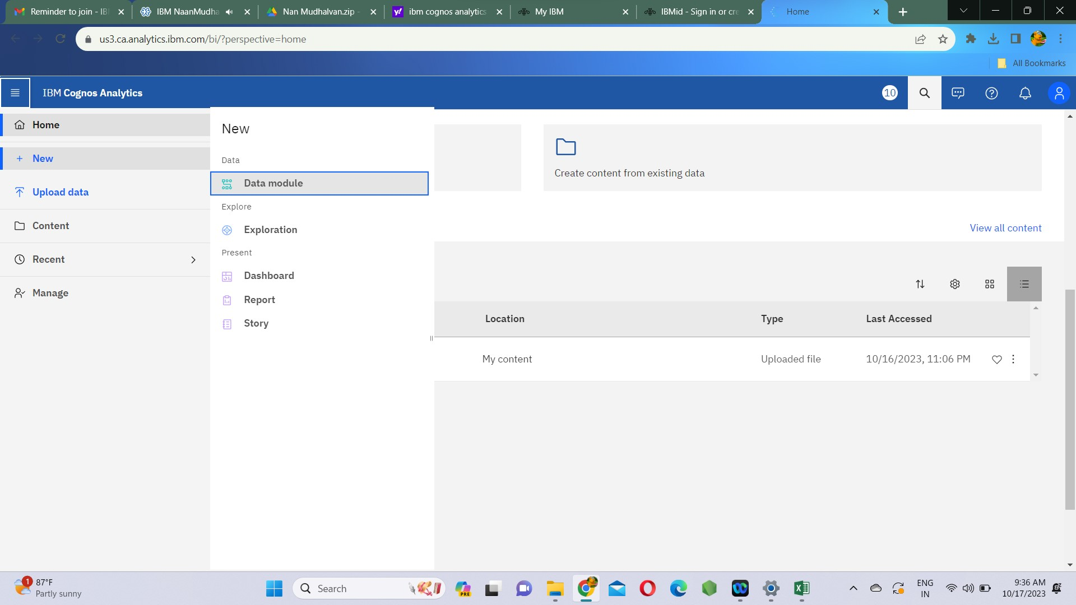

**Step3:** Also create a report in which we make the data visualizations.

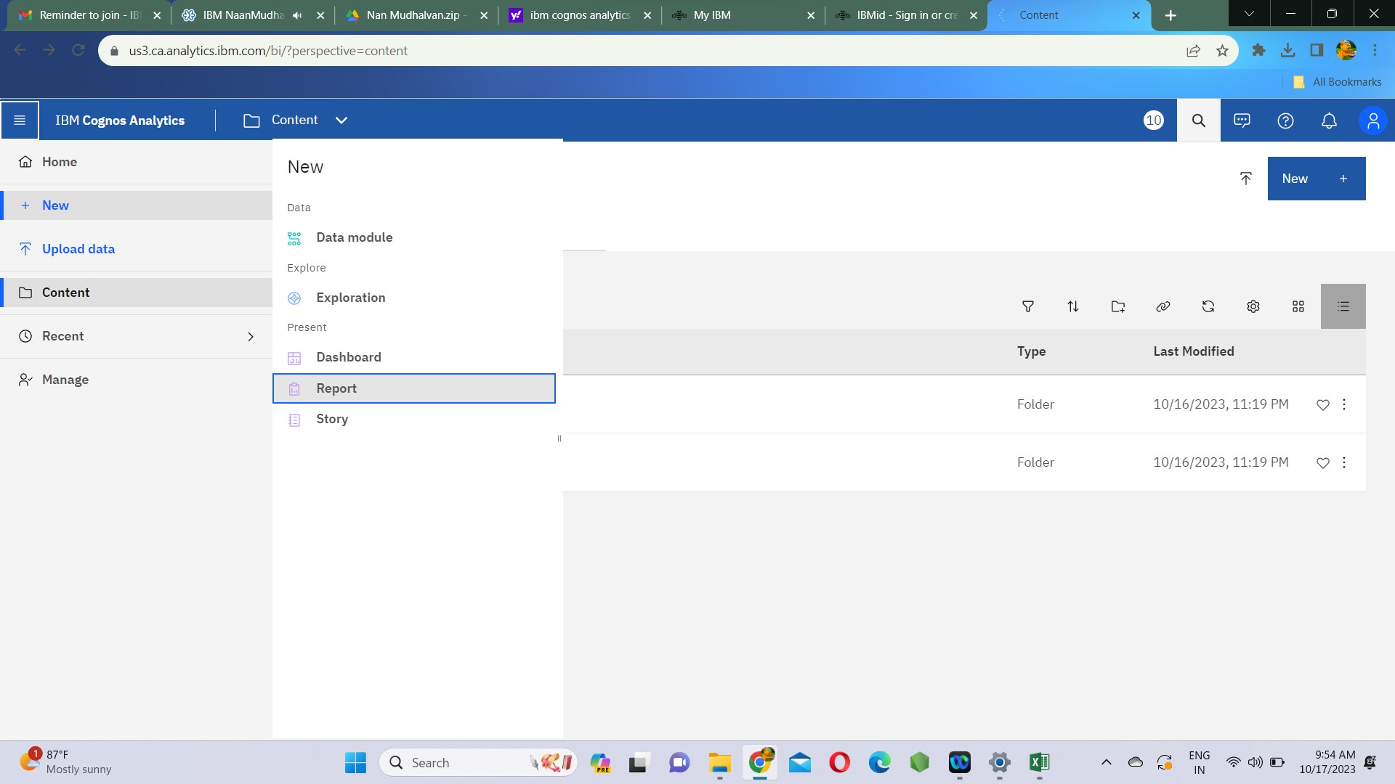

**Step4:** Select the csv source file for data visualization in report by clicking on select source. Also select templates and themes of the report.

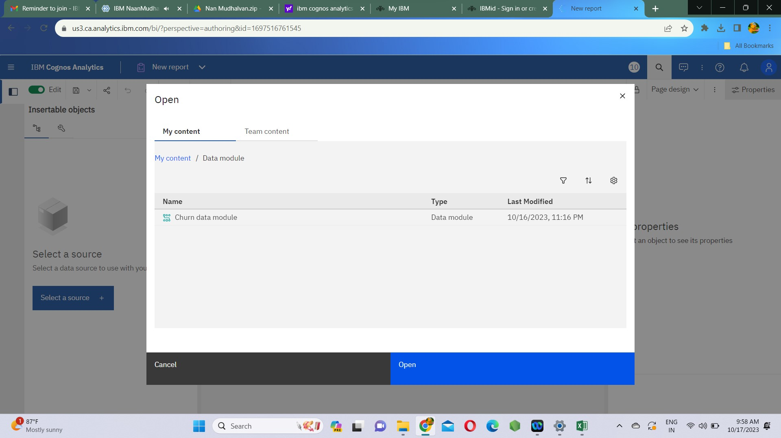

**Step5:** Select visualization under the select widget type.

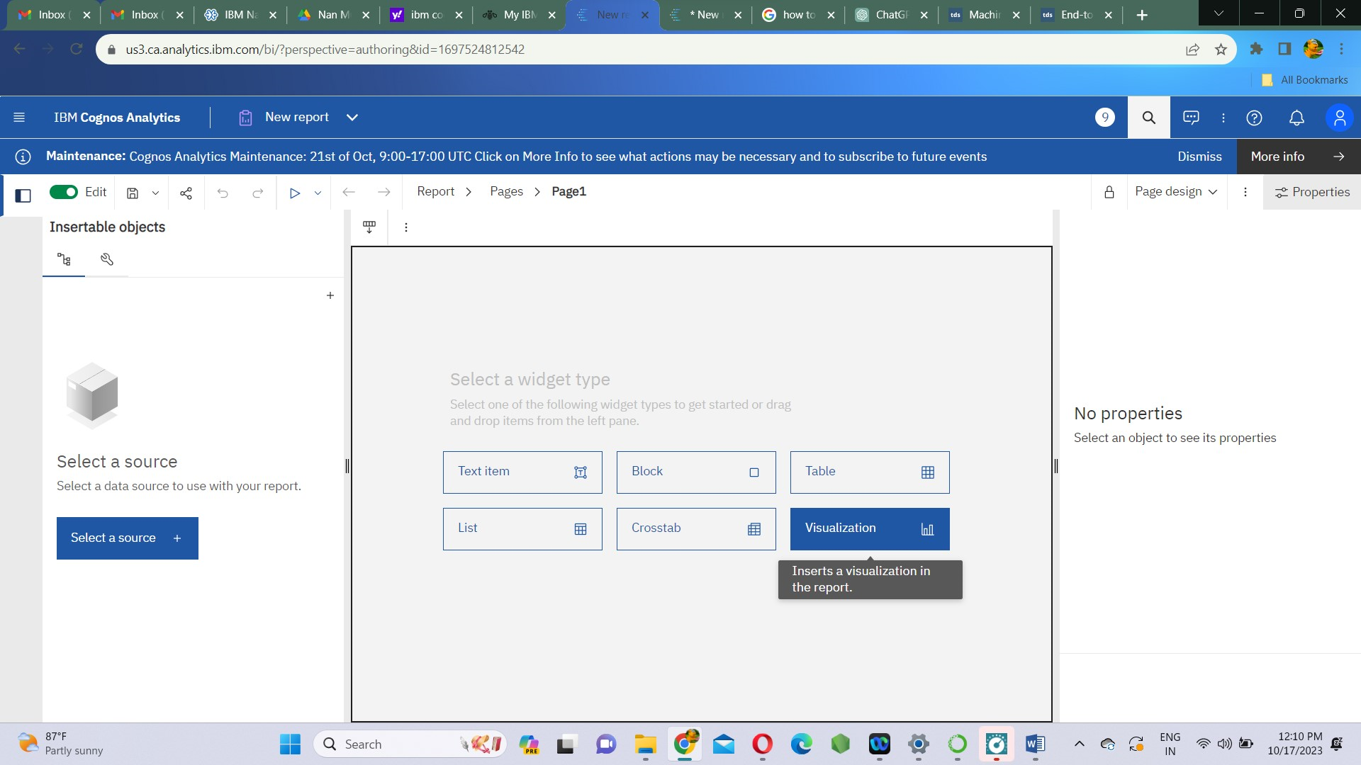

**Visualizations:**

We visualize the data in the form of bar plots and stack plots. By this we can understand the relation between various features of the dataset .

1. **Churn Vs Churn(count)**

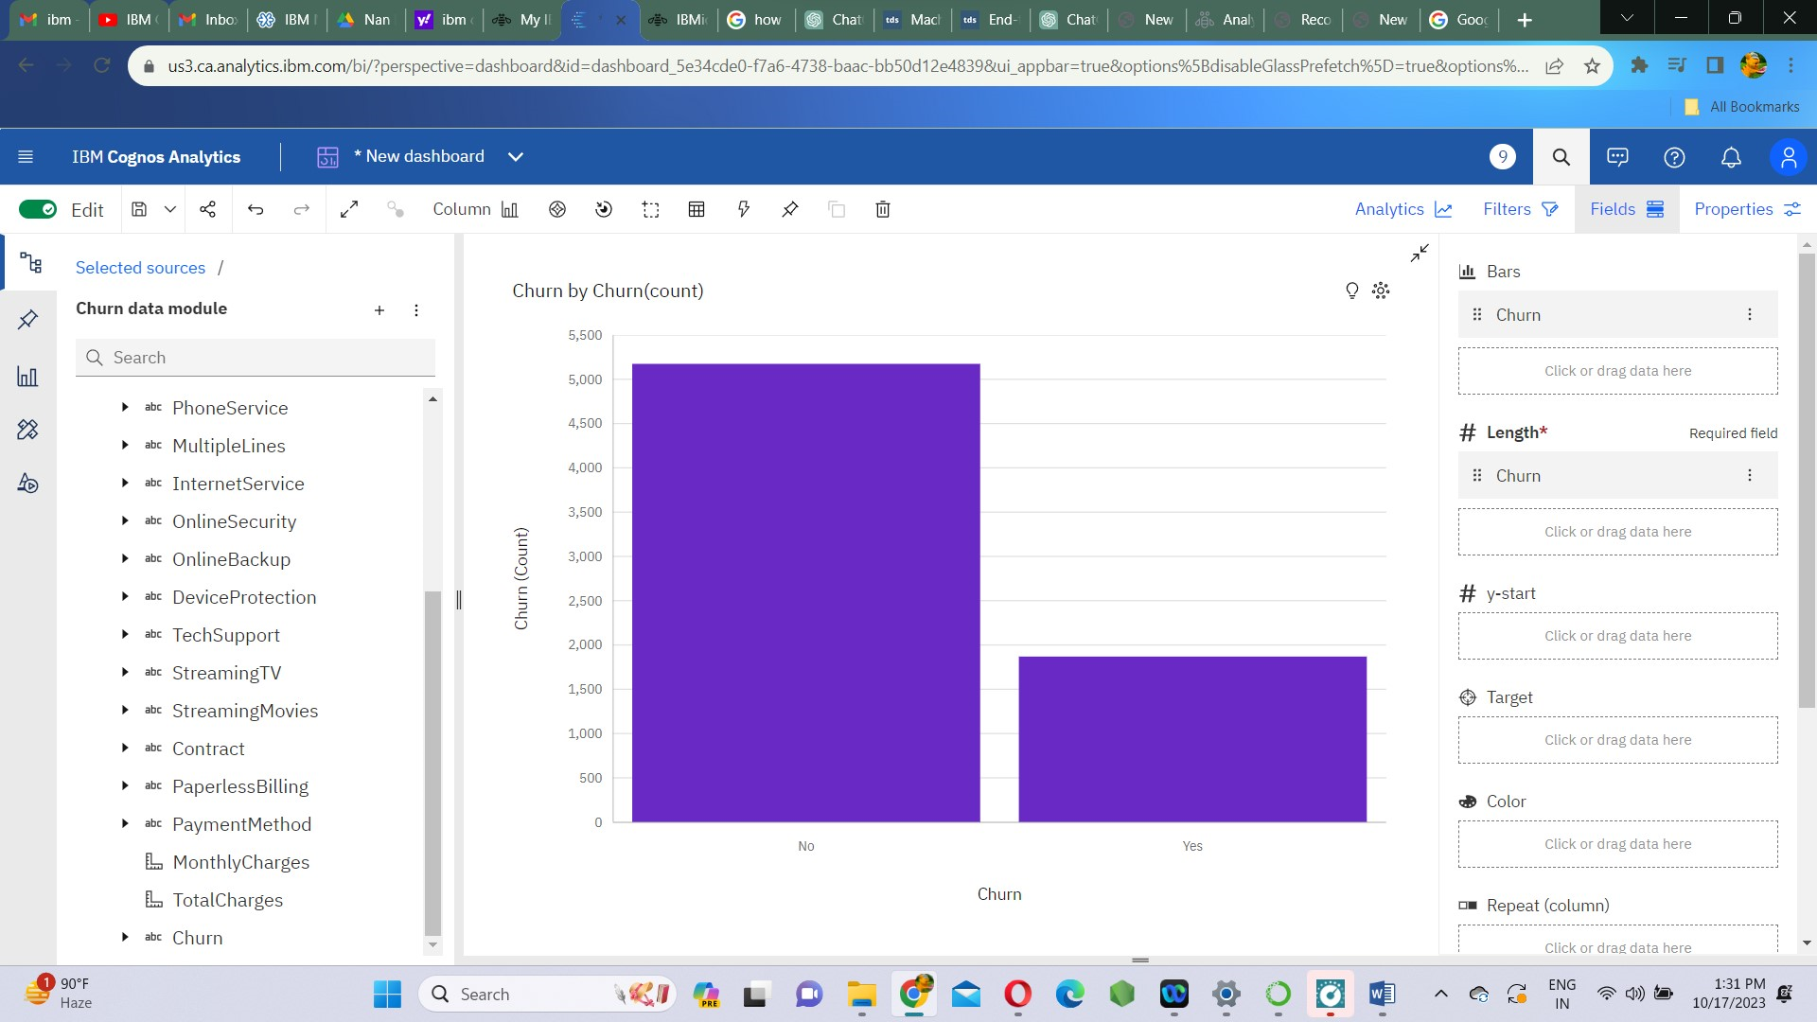

1. **Contract Vs Churn(count)**

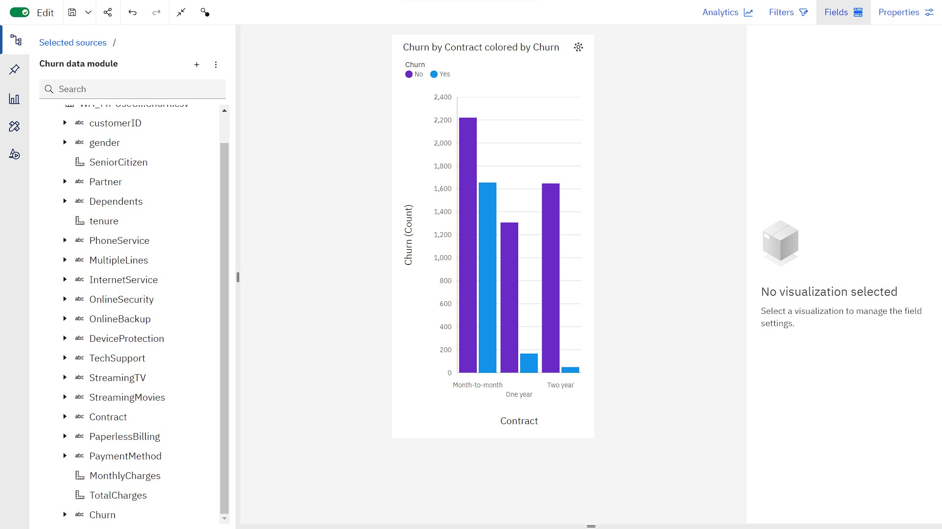

1. **SeniorCitizen Vs Churn(count)**

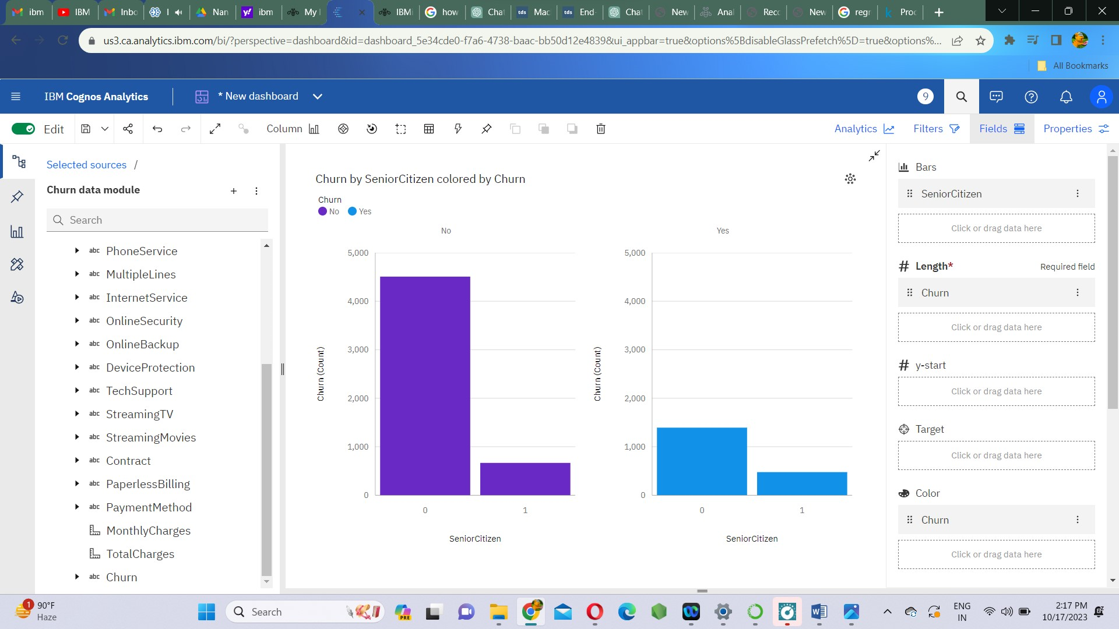

1. **gender Vs Churn(count)**

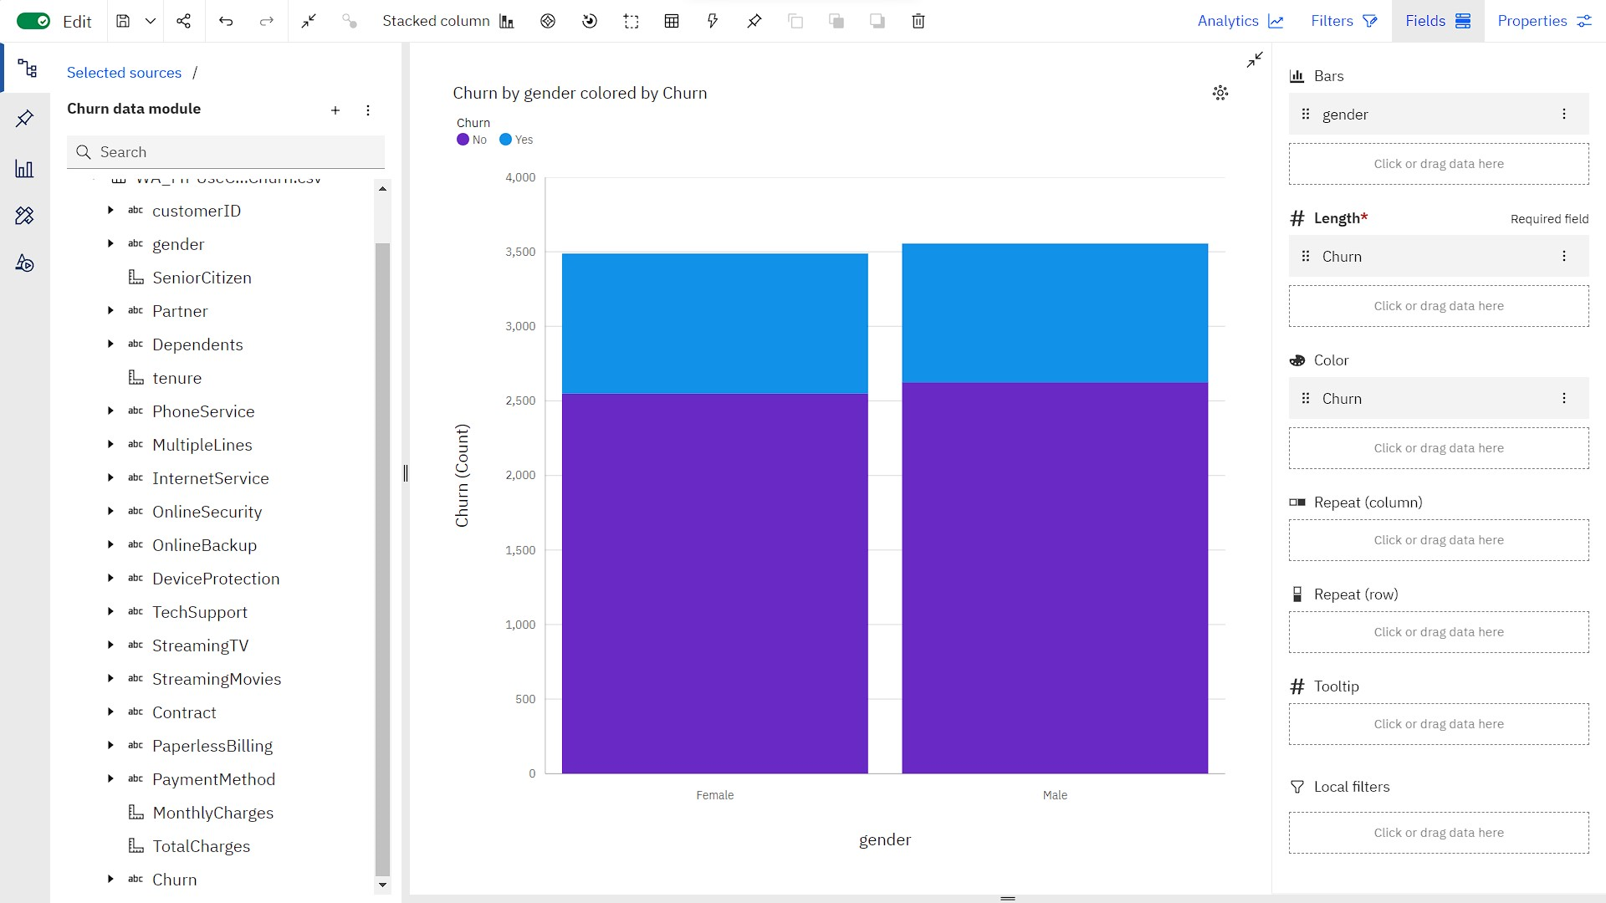

**Program file:**



|  |  |
| --- | --- |
| **TEAM ID** | **PROJ_224694_TEAM_2** |
| **TEAM MEMBERS** | **S.RAJARAJESHWARI**  **SANDHIYA.S**  **PRIYADHARSHINI .S**  **KOKILA.U**  **VISHNUPRIYA P** |
| **NAME** | **VISHNUPRIYA P** |
| **REGISTER NUMBER** | **420421205025** |